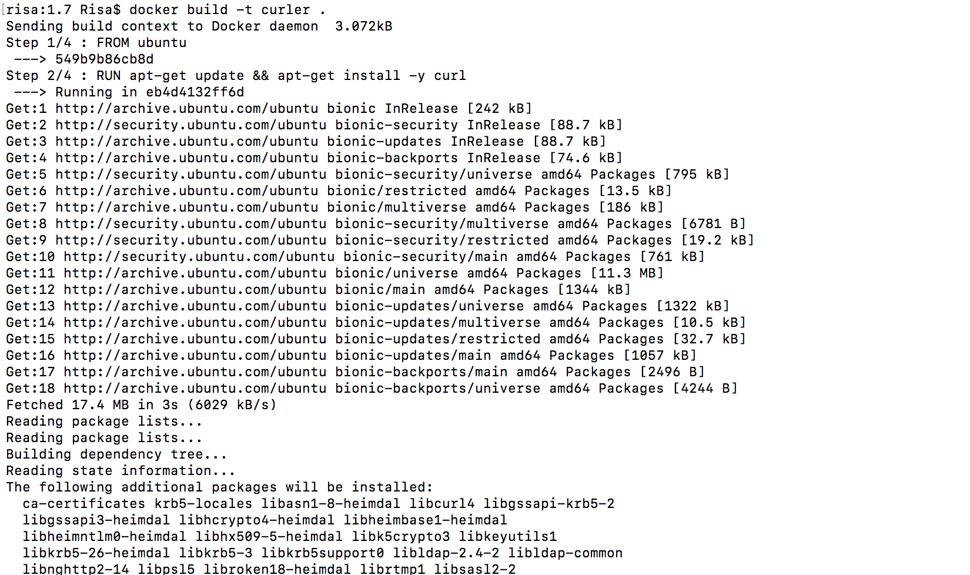# docker build -t curler .

#docker run -it curler

